

Dark Matter in Spiral Galaxies

Mass from Motion

Activity - After visiting the Observatory

Outline

In this project you will gain insight into why astronomers think there are large amounts of dark matter in galaxies. Dark matter is material that is “dark” in the sense that it neither absorbs nor emits electromagnetic radiation (“light”). We can infer its presence through the gravitational effect it has on the matter we can see (stars and gas).

Material List:

* Ruler
* Paper
* Pen
* Calculator

Procedure:

* What should students do?

|  |  |
| --- | --- |
| Step: | To Do: |
| 1 | Determine the inclination angle of the galaxy relative to the plane of the sky |
| 2 | Determine the Doppler-shift of the H-α line at each end of the galaxy |
| 3 | Determine the rotational velocity of the galaxy at each end (correct for inclination) |
| 4 | Assume spherical symmetry and determine the total mass of the galaxy |
| 5 | Compare with the mass of the gas and stars. Is there evidence for dark matter? |

# Introduction:

In the project we will work on the galaxy NGC493. You can see an image of the galaxy here:

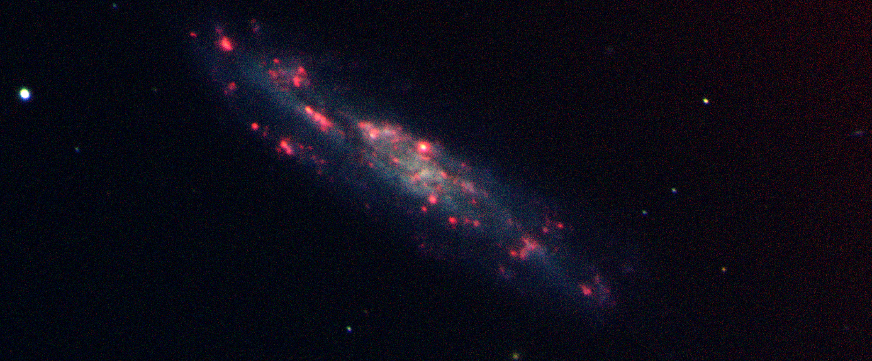

Figure 1: The galaxy NGC493 observed with Nordic Optical Telescope on La Palma. The blue light is stellar light recorded in two broad filters (B and V), whereas the red light is emission from hydrogen gas (H-α).

In order to measure how the galaxy rotates (if at all) astronomers make what is called “spectroscopy” whereby light from the galaxy is dispersed as a function of wavelength. The procedure is illustrated in Fig. 2.



Figure 2: The procedure behind taking a spectrum of the galaxy NGC493. The first image below to the left shows an image of the galaxy rotated such that the major axis of the galaxy is aligned horizontally. The next image is just a zoom-in of the first image. Next, a thin slit is placed in front of the galaxy such that only a narrow row of light along the major axis is recorded. Finally, to the right, the spectrum is recorded by dispersing the light in the slit vertically (blue towards the top, red towards the bottom). The top image shows a zoom-in on the spectral region around the H-α emission line. The rotation of the galaxy can be inferred from the tilt of the H-α emission line along the major axis of the galaxy (blueshifted to the left, redshifted to the right).

# Physics behind the exercise

The physics behind the exercise consists of two main elements: 1) the dynamics of circular motion, and 2) the Doppler-shift of spectral lines due to velocities along the line-of-sight.

First, in order to keep an object in circular motion a force is needed pointing in the direction of the center of the circle. Remember, Newton’s first law that states that any object not affected by external forces will be in a state of uniform motion (along a straight line with constant velocity). As an example, the planets in our Solar system are approximately in circular motion around the sun and the force is the gravitational force of the Sun. In the case of a spherically symmetric mass distribution the relation between the speed *v* of the circular motion and the mass *M(r<R)* within an orbit with radius *R* is given by:

$\frac{v^{2}}{R}=\frac{GM(r<R)}{R^{2}}$,

where *G* is the gravitational constant (*G*=6.67×10-11 m3 kg-1 s-2).

The Doppler-formula provides the spectral line shift, *Δλ*, caused by motion with velocity *v* along the line-of-sight:

$\frac{Δλ}{λ}=\frac{v}{c},$

where *c* is the speed of light. These are the two physical relations we need in this exercise.

# The measurements

The first step is to determine the inclination angle of the galaxy. As the Doppler-effect only measures the motion along the radial direction we need to consider the fact that the galaxy is inclined relative to the plane of the sky. If the galaxy was observed “edge-on” there would be no correction as the radial velocity would trace the full rotational velocity of the system. In order to determine the inclination angle, we assume that the galaxy would be a perfect circle when seen “face-on” and that the inclination angle can be determined from the axis ratio of the ellipse formed by projecting an inclined thin disk on the sky. Try to measure the ratio between the major axis *a* and the minor axis *b* and determine the inclination angle from this ratio:

$\sin{θ}=\frac{b}{a}$.

Use Fig. 3 to measure the inclination angle by measuring the axis ratio with a ruler.

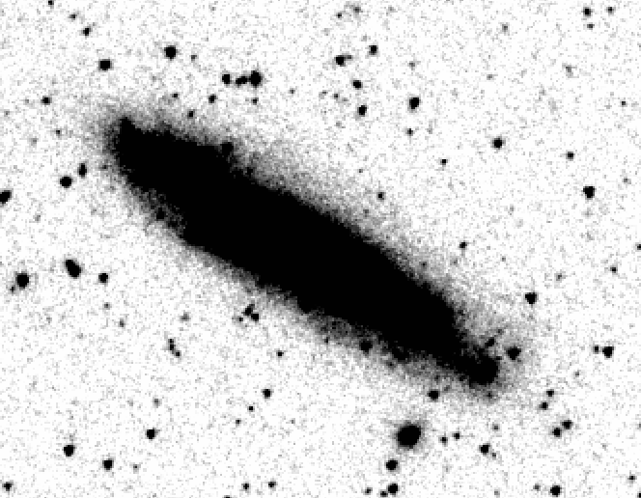

Figure 3: An infrared image of the galaxy (taken with the Spitzer space telescope). Use this to determine the inclination angle of the galaxy relative to the plane of the sky.

Next, we need to measure the Doppler-shift. In Fig. 4 is plotted the measured wavelength of the H-α emission line as a function of distance from the centre of the galaxy (in units of kpc, 1 pc = 3.09×1016 m). 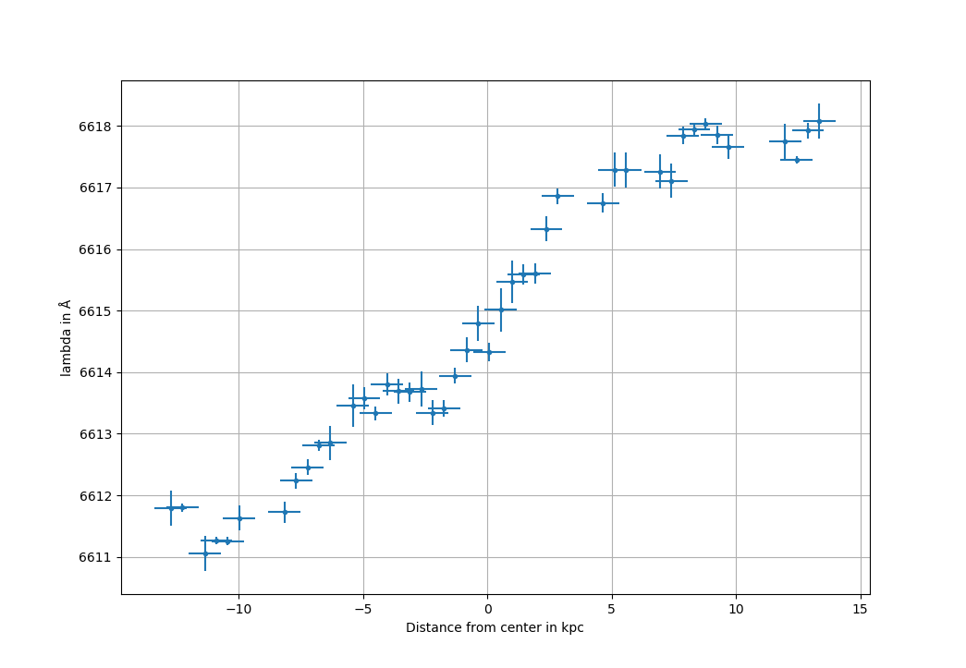

Use this graph to determine to velocity as a function of distance from the center. If you wonder about the velocities you infer remember that the galaxy as a whole is moving away from us due to the expansion of the Universe. Next calculate the total mass of the galaxy within a radius of about 13-14 kpc (remember to correct for the inclination).

The total gas mass of the galaxy is 9.08×109 solar masses (1 solar mass = 2×1030 kg) and the total stellar mass is 9.27×109 solar masses. These masses have been determined from the electromagnetic emission from the galaxy. Is there evidence for more mass than that that can be accounted for by gas and stars?