Formation of the Moon

Craters in the classroom!
Material List  - Top lid of A4 carton box  - Plastic bag  - Fine sand or flour 1 kg  - Glitter 25-50 g  - Chocolate powder 50-75 g  - 2-3 small marbles  - Ruler  - Sieve  - Phone camera | Outline  In groups, pupils will perform this classroom experiment to investigate how craters are formed when a small asteroid strikes the lunar surface. In this experiment you will compare the craters that you have formed with images of real craters observed on the moon.

Procedure
1. Wrap the plastic bag around the top lid of an A4 carton box.
2. Put the fine sand (or flour) into the plastic wrapped box.
3. Use a ruler to make sure the layer of sand is level. This layer represents the base material.
4. Sprinkle a thin layer of glitter on top of the flour. This layer represents rocks.
5. Use the sieve to sprinkle chocolate powder on top of the glitter. This layer represents the top lunar soil.
6. Compare your investigation with the images of lunar craters on the next page.
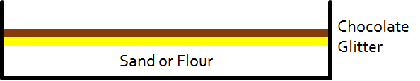

Investigation
Drop marbles from different heights. What happens?

Drop two or more marbles next to each other. What happens?

Throw marbles from different angles. What happens?

Throw marbles from very low angles. What happens?

Based on your observations, how do you think a crater on the Moon was formed?

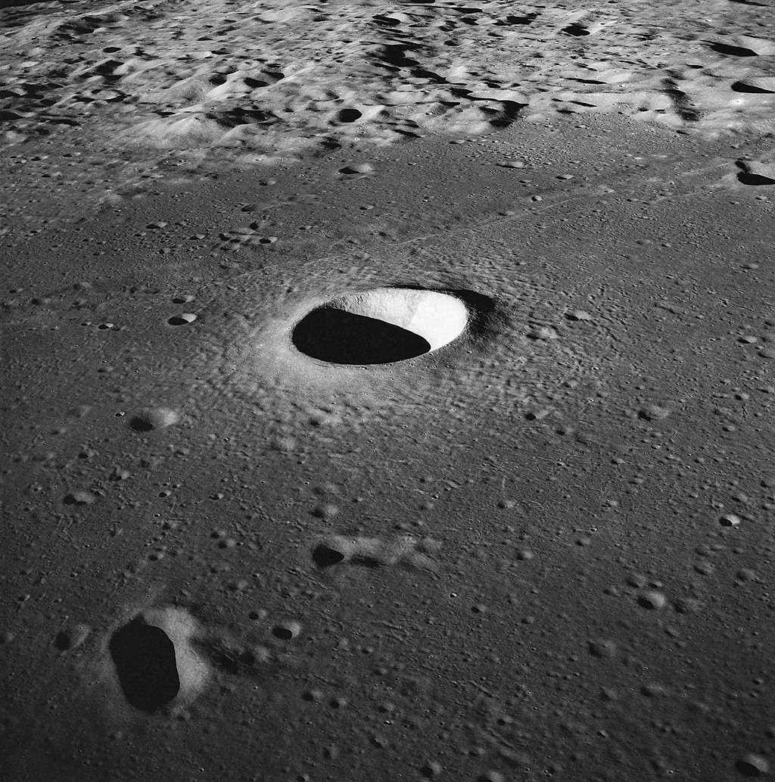  Moltke crater taken from Apollo 10 | 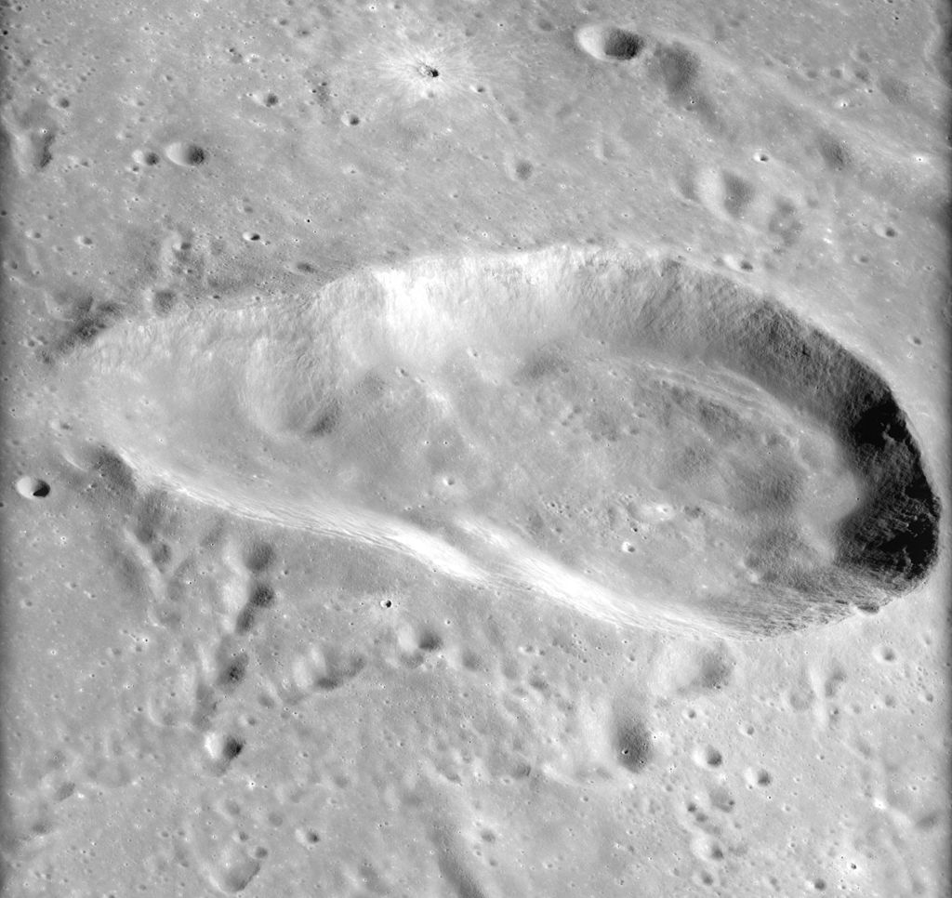  View of the Torricelli crater from Apollo 16
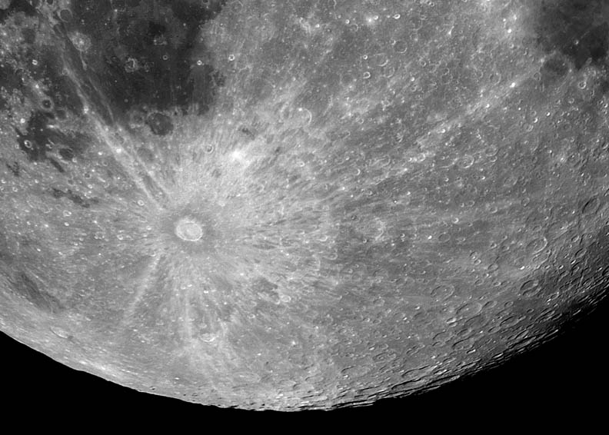  The large Tycho crater with white outwards rays. | 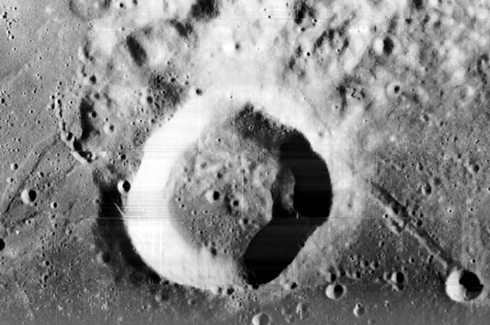  Webb crater taken from Lunar Orbiter 1
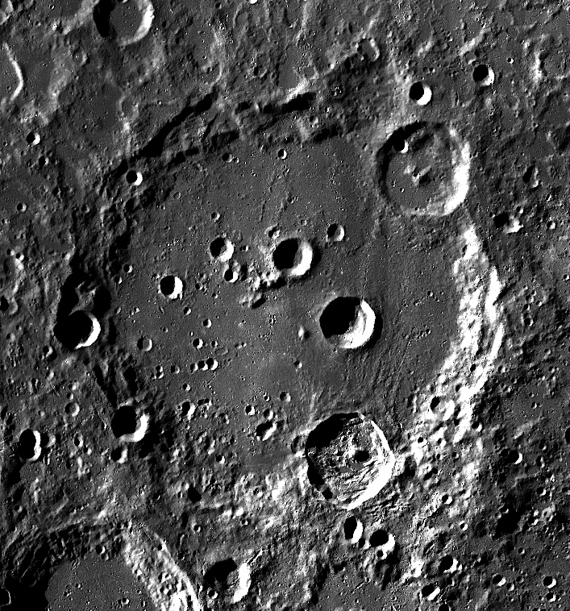  The large Clavius crater with smaller craters inside. | 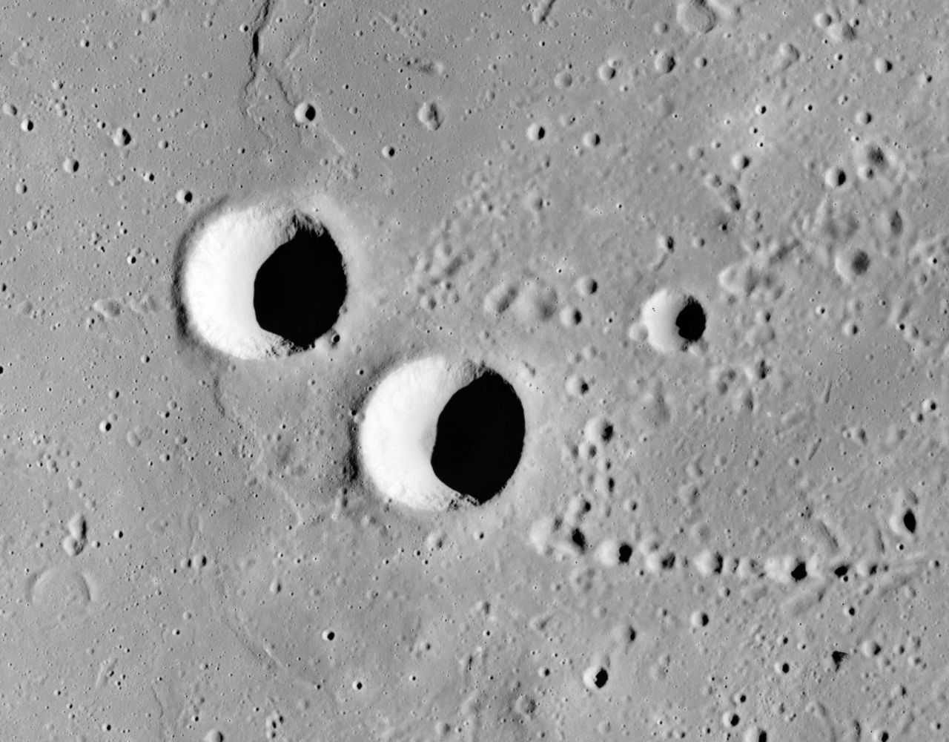  Feuillée (upper left) and Beer (lower right) craters

